Welcome to Pre-K
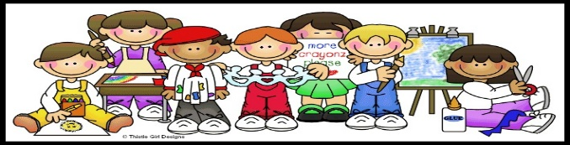

Blended School Supply List
Your child’s school supplies will only be used by them
1 backpack (no wheels)
1 reusable snack bag and lunch box
1 snap lock water bottle
1 smock
2 boxes of thick pencils
1 plastic pencil box
2 plastic folders
1 Ream of White Computer paper
1 box of washable Crayola Thick Markers
2 black Expo markers
2 boxes Jumbo Crayola Crayons- 8 Count
2 jumbo Elmer’s glue sticks
1 Bottle of Elmer’s school glue
1 Fiskars Preschool Learn to Cut Scissors
2 boxes of tissues
1 box of non-scented baby wipes
1 box of large ziplock bags
1 roll of paper towels
1 bottle of soap
1 large bottle of hand sanitizer
Cubby Clothes- All Labeled with Name
1 Large Labeled Ziplock Bag of Change of Clothes (Underwear, sweatpants, tee shirt, socks, shoes)
2 Reusable Cloth Masks
For Rest Time- Blankets and Sheets will Be Sent home at the end of the week for cleaning
1 Nap Mat or Blanket
1 Twin Size fitted sheet (Not crib size please)
1 Small Reusable Duffle bag for Sheets
Welcome to Pre-K

Virtual Learning School Supply List
Your child’s school supplies will only be used by them

1 box of washable Crayola Thick Markers
2 black Expo markers
2 boxes Jumbo Crayola Crayons- 8 Count
4 Jumbo Elmer’s glue sticks
1 Bottle of Elmer’s school glue
1 Fiskars Preschool Learn to Cut Scissors
1 whiteboard
1 ream of construction paper
1 Crayola watercolors and paint brush
1 ream of white computer paper
1 black and white notebook
1 tablet or laptop (provided by NYCDOE)
1 Printer and ink *recommended*
- Other materials will be required for Pre-k projects throughout virtual learning

